2.1 Explain how processes and forces affect the lithosphere
- Explain how the rock cycle, plate tectonics, volcanoes, and earthquakes impact the lithosphere.
- Match the type of rock that forms due to the following
- ___Igneous  - ___Metamorphic  - ___Sedimentary | - Melting and Cooling  - Heat and pressure  - Weathering/erosion  and compaction | 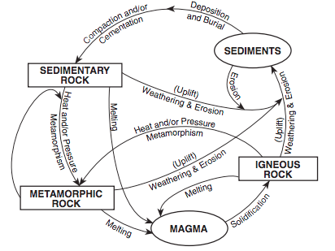

B. Explain the theory plate tectonics
_______________________________________________________________________________________________________________________________________________________________________________________________________________________________________

C. All of the following support the theory of continental drift except _____.
A. The continents seemed to fit together like pieces of a puzzle.
B. There are similar fossils on different continents.
C. Mountain ranges on different continents lined up.
D. The North Pole and Antarctica are covered in ice.

D.What hypothesis states that the continents were once joined to form a single supercontinent?
a. | plate tectonics | c. | continental drift
b. | seafloor spreading | d. | paleomagnetism

E. Use the word bank below to complete the sentences.
seismograph Sea floor spreading earthquakes melt P Waves
Epicenter Continental-continental Metamorphic S Waves

1. Which of the following occur at divergent boundaries? ________________________
2. An earthquakes _____________________ is occurs directly above the focus.
3. Mountains form at ________________________________ convergent boundaries.
4. ________________ rocks form due to heat a pressure.
5. Magma forms when rocks from the upper crust and mantle ______________________.
6. A _________________________ is the instrument that records earthquake waves.
7. _____________ shake particles at a right angle to the direction of travel. ________________ change a materials volume by expansion and compression.

8. Predictions are made on the assumption that __________________ are repetitive (they occur on the same fault lines).

F. Match structures formed at each plate boundary
A B C
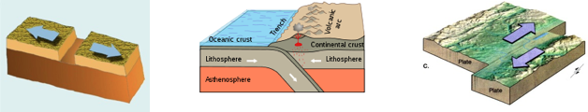
____ 1. Convergent ____ 2. Divergent ____ 3. Transform

C. Explain what happens (plate motion) and what features occur at each plate boundary.
Convergent ( Hint: Three types)
______________________________________________________________________________________________________________________________________________________________________________________________________________________________________________________________________________________________________________________________________________________________________________________________________________________________________________________________________________
Divergent (Hint: Two types)
______________________________________________________________________________________________________________________________________________________________________________________________________________________________________________________________________________________________________________________________________________________________________________________________________________________________________________________________________________

Transform
_______________________________________________________________________________________________________________________________________________________________________________________________________________________________________

G. In the chart below compare and contrast magma and lava.
Magma | Lava

2. Locate volcanoes and relate back to plate boundaries. Explain volcanic effects on the lithosphere and relate back to plate boundaries (convergent, divergent, transform) including lahar (mud) flows and ash in the atmosphere.
A. Circle the best answer
1. Most of the active volcanoes on Earth are located in a belt known as the ____.
a. | Ring of Lava | c. | East African Rift Valley
b. | Ring of Fire | d. | circum-Atlantic belt

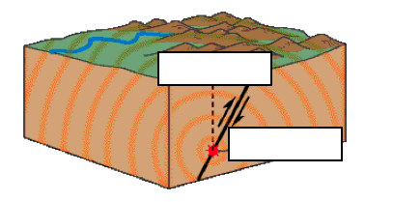
- Label the epicenter and focal point.

- At which type of plate boundary do earthquakes typically occur?

- Complete the chart below.
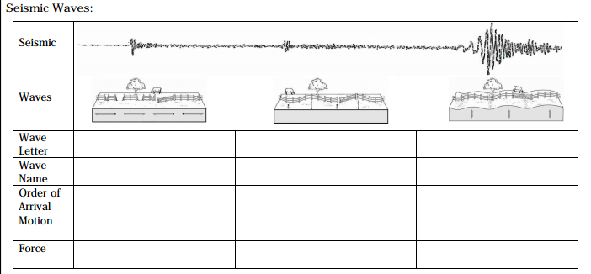
- • Summarize the major events in the geologic history of North Carolina and the southeastern United States.
1. ___ Appalachian Mountains  2. ___Fall Zone  3. ___ Shorelines  4. ___Barrier Islands  5. ___ River Basins | a. due to uplifting of rock in the western part of NC  b. line of erosion between piedmont and coastal plains  c. affected by erosion due to increase in sea level  d. built up by sediment from rivers, and constantly changing due to wave action  e. area of land that contributes water to a rvier

- What is currently happening to global sea level? Why?

3. Explain how natural actions such as weathering, erosion (wind, water and gravity), and soil formation affect Earth’s surface.
A. Describe the following processes:
Weathering | Erosion | Soil Formation

B. Mass Movements:
___1. The downslope movement of rock, regolith, and soil under the direct influence of gravity is called a(n) _____________. | ___2. A mass movement that involves the sudden movement of a block of material long a flat, inclined surface is called a _____.  a. Slide b. Slump  c. Flow d. Rockfall
3. The downward movement of a block of material along a curved surface is called a(n) ________. | ___4. What is the slowest type of mass movement?  a. Earthflow b. Slump  c. Creep d. Rockfall
___5. What factor(s) commonly triggers mass movement?  a. Earthquakes  b. Saturation of surface materials with water  c. Removal of vegetation  d. All of the above | ___6. What is the force behind mass movement?  a. The sun’s energy  b. Gravity  c. Flowing water  d. Moving ice

C. Earthquakes:
1. What are the causes of damage during or after an earthquake (5 in total)?  1) _________________________________  2) _________________________________  3) _________________________________  4) _________________________________  5) _________________________________ | 2. How can we predict earthquakes?  ________________________________________________________________________________________________________________________________________________________

___3. Which of the following affects the amount of destruction caused by earthquake vibrations?  a. The design of structures  b. The nature of the material on which structures are built  c. The intensity and duration of the vibrations  d. All of the above | ___4. What is the minimal number of seismic stations that is needed to determine the location of an Earthquake’s epicenter?  a. One  b. Two  c. Three  d. Four
5. Explain the hazards to humans from an earthquake:
___________________________________ ___________________________________ ___________________________________

D. Volcanoes:
___1. The particles ejected in volcanic eruptions are called _____.
a. Calderas
b. Volcanic stocks
c. Laccoliths
d. Pyroclastic material

___3. Most of the active volcanoes on Earth are located in a belt known as the ____.  a. Ring of Fire  b. Ring of Lava  c. East African Rift Valley  d. Mid-Pacific Rise | ___4. Which of the following factors helps determine whether a volcanic eruption will be violent or relatively quiet?  a. amount of dissolved gases in the magma  b. temperature of the magma  c. composition of the magma  d. all of the above

Explain precautions that can be made to protect life from various geohazards . Some examples include landslides, earthquakes, tsunamis, sinkholes, groundwater pollution, and flooding.
________________________________________________________________________ ________________________________________________________________________________________________________________________________________________ ________________________________________________________________________

2.2 Understand how human influences impact the lithosphere.
- Explain the consequences of human activities on the lithosphere past and present.
A. Match each human activity to possible consequences
- ____ mining  - ____ deforestation  - ____ agriculture  - ____ overgrazing  - ____ urbanization | a. soil erosion  b. desertification  c. nutrient depletion  d. global warming  e. heat islands

2.3 Explain the structure and processes within the hydrosphere.
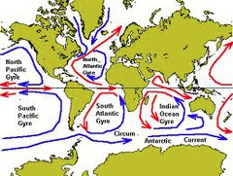
- Explain how water is an energy agent
A. Explain how warm and cold currents cycle.

B. Why are coastal cities warmer than inland cities?

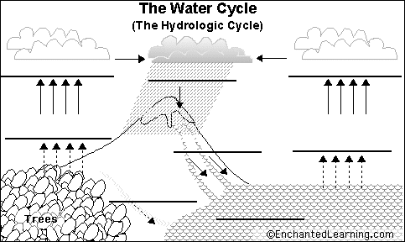
- Explain how ground water and surface water interact.
A. Label: evaporation, transpiration, precipitation, condensation, run off

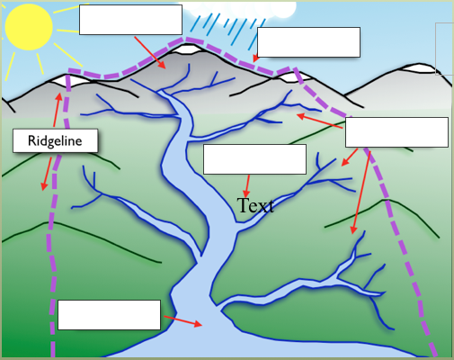

B. Label the watershed with: headwaters, estuary, floodplain, tributaries, precipitation

2.4 Evaluate how humans use water.
- Evaluate human influences on freshwater availability
A. Fill in the blank: well, aquifer, dams, agriculture, recreation, subsidence, salt water intrusion.
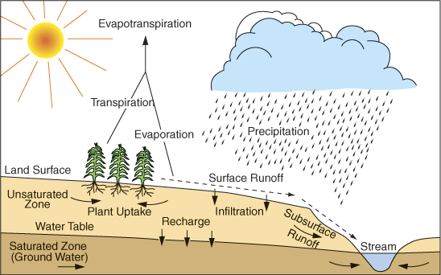
To access groundwater, _____________ are dug into _______________. The primary use of groundwater by humans is for ______________________. Issues with aquifers include ____________________ (sinking of sediment) and ____________________ (contamination of salt water by the coast).

B. Growing human population will ________________ freshwater as a resource. (increase or decrease).

C. True or False:
____________Pollution in the ground cannot affect freshwater.
____________Pollution at one area of a watershed cannot affect other areas of the watershed.
____________ A biotic index of macroinvertebrates can be used to determine water quality

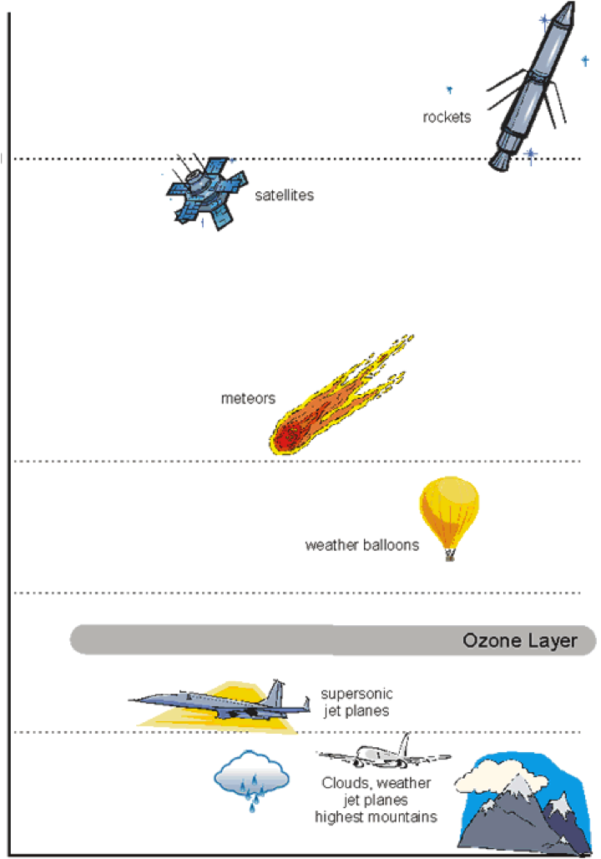
2.5 Understand the structure of and processes within our atmosphere.
- Summarize the structure and composition of our atmosphere.
A. Label the layers of the atmosphere to the right: thermosphere, troposphere, stratosphere, mesophere

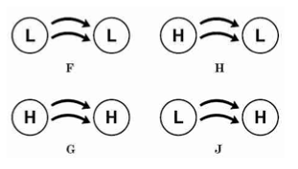
. Which diagram (F, G, H, or J) below shows how air masses move in the troposphere?
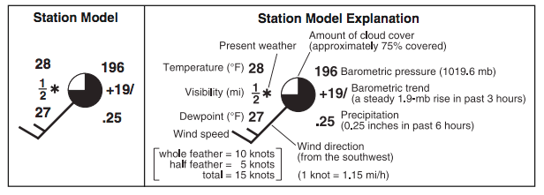
(H = high pressure, L = low pressure)
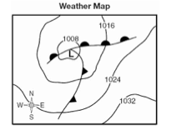

C. True or False:
_____________ warm moist air rises over cold dense air
_____________ rain occurs when warm moist air condenses at higher altitudes
_____________ higher elevations are colder than lower elevation
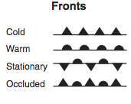
_____________ a cold front occurs when cold air masses push under a warm air mass. Narrow storms are produced
____________ wide bands of precipitation occur at warm fronts
___________ thunderstorms occur at warm moist air masses moving along a cold front
___________ tornadoes are measured by the Fujita Scale
___________ hurricanes are measured by the Saffir-Simpson Scale
___________ isotherms show lines of temperature
_______ isobars show lines of air pressure
_______ psychrometers measure humidity
_______barometers measure air pressure
_______ thermometers measure air temperature
__________ anemometers measure air speed
_______ a weather vane measure wind direction
__________ a rain gauge shows the amount of precipitation

- Explain how cyclonic storms form based on the interaction of air masses:
Hurricane Formation | Tornado Formation

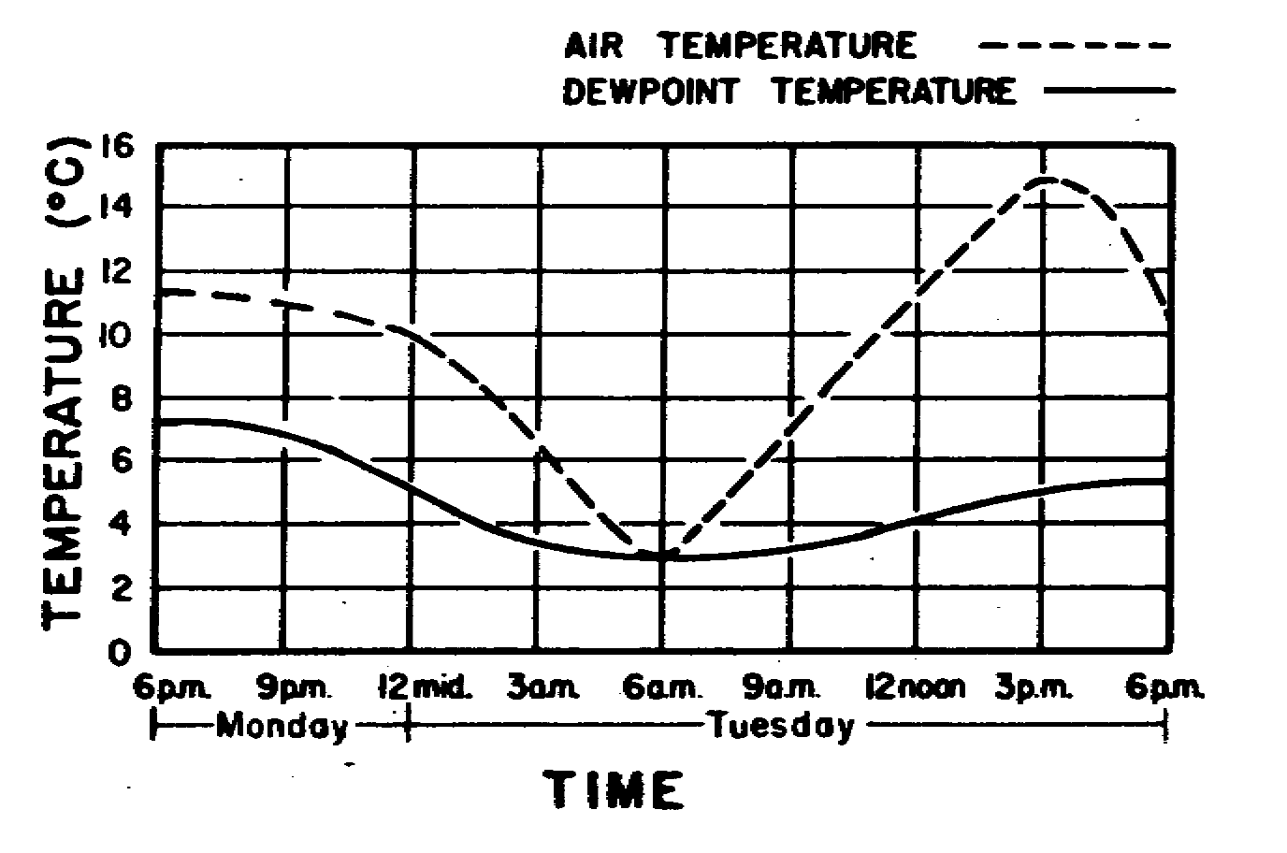
A. Why does dew form in the morning?

B. Explain how clouds form: (See diagrams below)

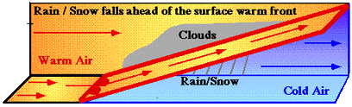
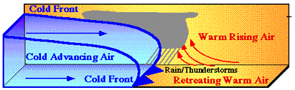

- Explain how human activities affect air quality
A. Match the following to their impact on the atmosphere
1. ____ Acid Rain  2. ____ chlorofluorocarbons (CFC’s)  3. ____ burning of fossil fuels | a. formed by sulfur dioxide and nitrogen oxides, decrease pH of precipitation  b. decreases ozone  c. increases the amount of greenhouse gases and sulfur dioxide and nitrogen oxides

2.6 Analyze patterns of global climate change over time
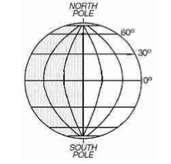
- Differentiate between weather and climate
A. True or False?
____ Temperate climates are located closest to the equator.
____ Polar climates are cold year round
____ Temperate climates have warm and cold seasons
____ Polar climates have the most precipitation
____ Tropical climates have the most varied climate

B. Compare weather and climate.
Weather | Climate

2. Explain changes in global climate due to natural processes.
A. Matching
1. ___ El Nino/La Nina  2. ___ volcanic eruptions  3. ___ sunspots  4. ___ shifts in Earth’s orbit  5. ____ carbon dioxide fluctuations | a unusually warm temperatures caused by a change in ocean currents  b. cause cooler temperatures due to absorption of sun’s energy by atmospheric particles  c. decrease in climate due to magnetic field changes of the sun  d. changes in climate due to the change in the tilt of Earths axis  e. increases climate when increase occurs

B. Explain the concept of the greenhouse effect and identify 2 greenhouse gases.
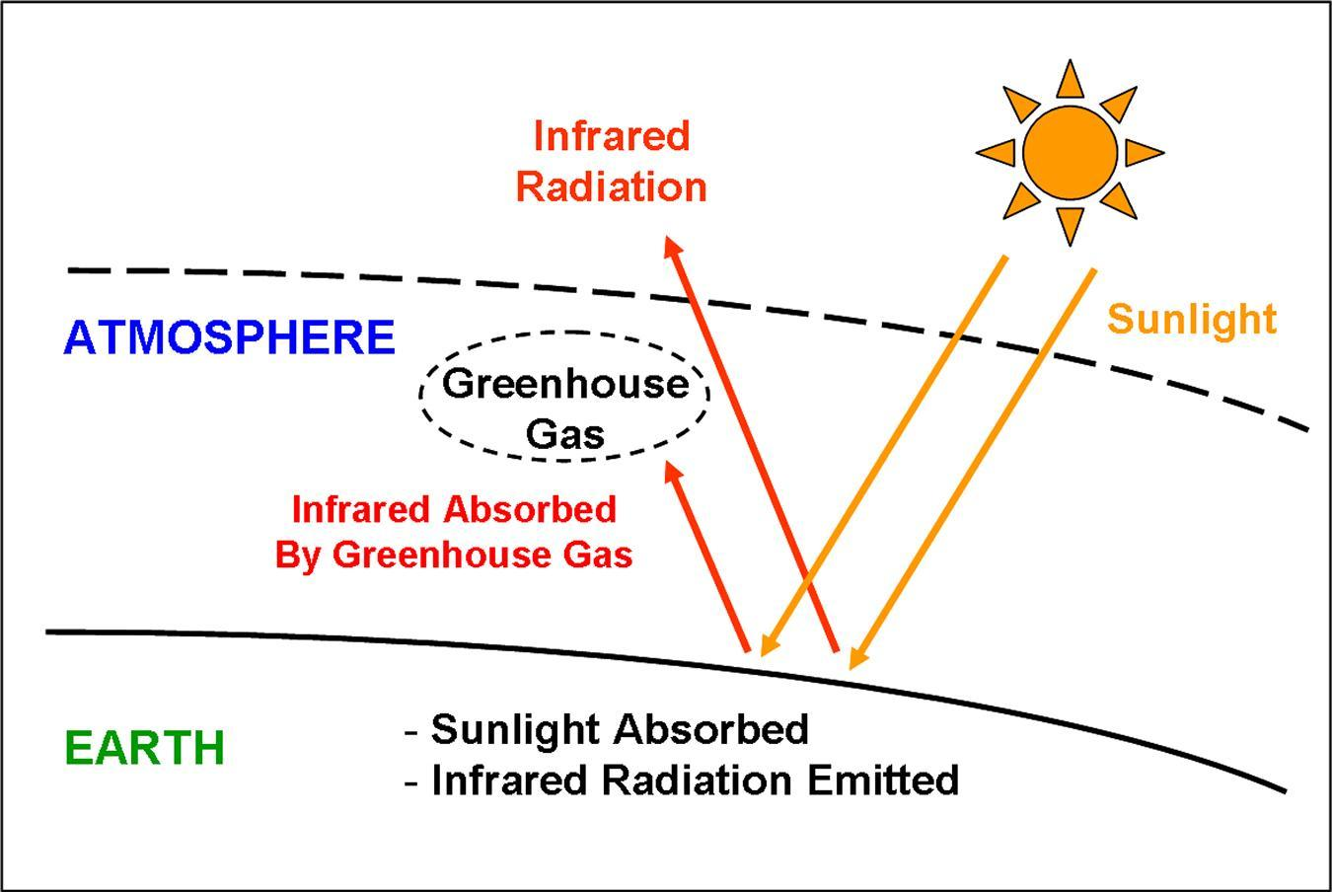

- Analyze the impacts that human activities have on global climate change (such as burning hydrocarbons, greenhouse effect, and deforestation).
A. Matching
1. ___ burning hydrocarbons  2. ___ greenhouse effect  3. ___ deforestation  4. ___ heat island  5. ___ industrialization | a. increases greenhouse gases (CO2) in the atmosphere  b. traps heat in the atmosphere  c. increases CO2 in the air and results in less CO2 being removed from the air by photosynthesis  d. urban areas that reflect more heat and produce more CO2  e. results in increased burning of fossil fules.

2.7 Explain how the lithosphere, hydrosphere, and atmosphere individually and collectively affect the biosphere.
- Explain how abiotic and biotic factors interact to create the various biomes.
A. Identify if the following factors of biomes are biotic or abiotic: temperature, rainfall, altitude, type of plant, latitude, type of animals.
Biotic | Abiotic

B. Explain why biodiversity is important.

C. Complete the chart
Human Influence | Effect
Human population growth
Habitat alteration
Introduction of invasive species
Pollution
Over harvesting

2.8 Evaluate human behaviors in terms of how likely they are to ensure the ability to live sustainably on Earth
- Evaluate alternative energy technologies for use in North Carolina.
A. Fill in the chart
Energy | Advantages | Disadvantages
solar
wind
biofuels
nuclear fission
fuel cells
wave power
geothermal
coal
oil
natural gas

B. Identify if the above energy sources are renewable or nonrenewable in the chart below:
Renewable | Nonrenewable

- Critique conventional and sustainable agriculture and aquaculture practices in terms of their environmental impacts.

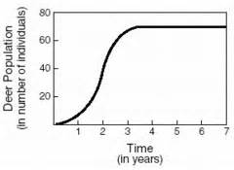
- Explain the effects of uncontrolled population growth on the Earth’s resources.
A. What is the carrying capacity of the following graph and explain?

B. What are three limiting factors for human population?

C. What will most likely happen if the human population continues to grow at current rates?
a. There will be fewer natural resources available for future generations.
b. There will be an increase in nitrogen levels in the atmosphere.
c. There will be a decrease in the number of strong hurricanes.
d. There will be a decrease in water pollution.

- Evaluate the concept of “reduce, reuse, recycle” in terms of impact on natural resources.
A. What is ecological footprint?
a. measures the amount of renewable and nonrenewable resources that are used by our activities
b. the maximum number of individuals that the environment can support
c. measure of how many people make up the world population

B. Identify one example of a material that could be reused. How could reusing the object provide a lasting impact on the environment?

1.1 Explain the Earth’s role as a body in space.
- Explain the Earth’s motion through space, including precession, nutation, the barycenter, and its path about the galaxy.
- Matching
- ___Rotation  - ___Revolution  - ___Precession  - ___Nutation  - ___Barycenter | - Day and Night (24 hrs)  - A Year (365 days)  - change in direction of the axis, but without any change in tilt—this changes the stars near (or not near) the Pole  - wobbling around the axis (This occurs over an 18 year period)  - the center of mass where two or more celestial bodies orbit each other(This is the point about which the Earth and Moon orbit as they travel around the Sun.)

- Fill in the blank
__________________ is made of ____________________ which are made of many _____________________. Some stars have planetary systems similar to our __________________. Earth is a ____________________of one particular star.
(star, galaxy, universe, satellite planet, solar system)

- The universe is ________________________ (expanding or contracting) after the Big Bang.

True or False.
1. _____ Kepler discovered that the path of each planet around the sun is an ellipse.
2. ____ The universe is made of galaxies, galaxies contain stars, stars may have planetary systems.
Identify Kepler’s Laws
__________ The line joining the planet to the Sun sweeps out equal areas in equal times as the planet travels around the ellipse.
__________ The ratio of the squares of the revolutionary periods for two planets is equal to the ratio of the cubes of their semimajor axes.
__________ The orbits of the planets are ellipses, with the Sun at one focus of the ellipse.

2. Explain how the Earth’s rotation and revolution about the Sun affect its shape and is related to seasons and tides.
- Fill in “tide” or “season” for the chart
due to the approximate 23.5 degree  tilt and revolution of the Earth | due to the  gravitational interaction between the Earth and moon

- Describe Earth's shape

3. Explain how the sun produces energy which is transferred to the Earth by radiation.
C. What is our main source of electromagnetic energy?_________________ | D. True or False.  Energy produced by the Sun is transferred to earth by radiation. ________________
E. Explain Nuclear Fusion.  _________________________________________________________________________________________________________ | F. Explain Nuclear Fission.  ________________________________________________________________________________________________________
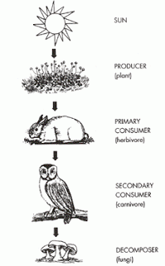
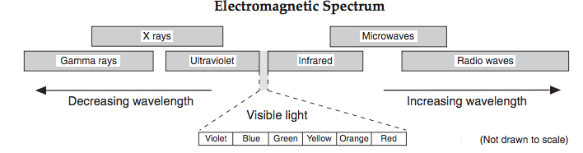

- Explain how incoming solar energy makes life possible on Earth.
- What is photosynthesis?

- Explain how the suns energy moves through the food chain

